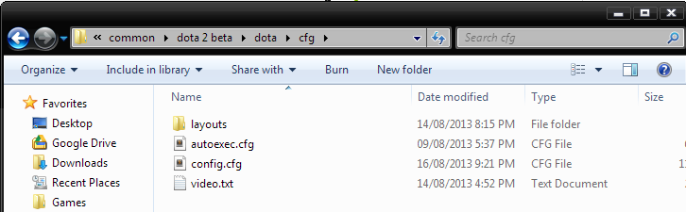

Organize v Include in library v Share with v Burn New folder {FEE ' E] Q \* Favorites Name Date modified Type Size I Desktop layouts 14/08/2013 8:15 PM File folder {5 Google Drive g] autoexec.cfg 09/08/2013 5:37 PM CFG File I m Downloads L1 config.cfg 16/08/2013 9:21 PM CFG File 11 E Recent Places videobc‘t 14/08/2013 4:52 PM Text Document

H Games